**Project Design Phase -II**

**Data Flow Diagram and User Stories**

|  |  |
| --- | --- |
| Date | 23 October 2023 |
| Team ID | Team-591797 |
| Project Name | Vitamin Detection Using Deep Learning |
| Maximum Marks | 4 Marks |
| Team Size | 4 |
| Team Members | Kasibhatla Srichandana Pothala Jaya Sri Sindhu  Karthikeya J  Bhanu Bhargavi Mamidikuduru |

# Data Flow Diagrams:

A Data Flow Diagram (DFD) is a visual representation that shows how information flows within a system. It is a traditional method used to depict the system requirements in a clear and concise manner. A well-designed DFD can help in understanding how data enters and exits the system, what processes the information goes through, and where the data is stored. In short, it provides a clear picture of the data flow within a system.

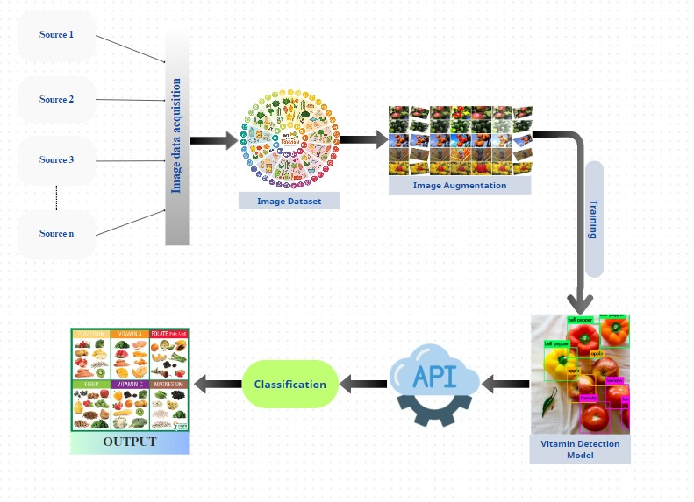

**DFD Level 0:**

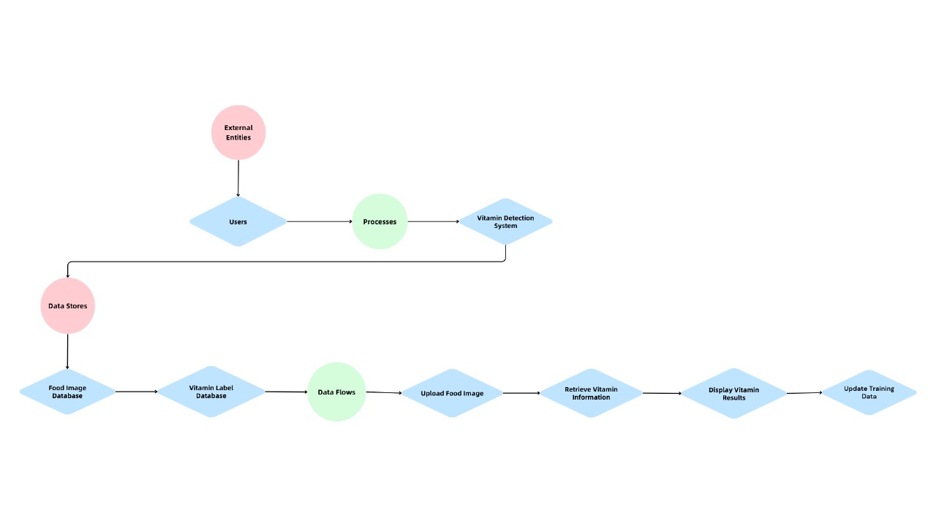

**User stories:**

|  |  |  |  |  |  |  |
| --- | --- | --- | --- | --- | --- | --- |
| **User Type** | **Functional Requirement (Epic)** | **User Story Number** | **User Story / Task** | **Acceptance criteria** | **Priority** | **Release** |
| Government health management oraganizations | Project setup & Infrastructure | USN-1 | As a dietitian, I want detailed vitamin breakdowns based on food images. | The system should provide a detailed report of vitamins detected in the patient's diet, with clear categorization and accurate quantities. | High | Sprint 1 |
| Hospitals | Development environment | USN-2 | The system should include a knowledge base that provides healthcare professionals with information on the patients daily vitamin intake. | The system should support continuous improvement, allowing healthcare professionals to provide feedback and contribute to the system's ongoing training and optimization. | Medium | Sprint 2 |
| Households and Individuals | Data collection | USN-3 | As a parent, I want the system to notify me if my child's meal contains allergens. | The system should identify common allergens in the food and provide immediate notifications if detected. | High | Sprint 1 |
| Researchers | data preprocessing | USN-4 | The system should accurately analyze images of packaged food items and verify the nutritional claims on product labels. | The system should allow bulk image uploads and should correctly process all images for vitamin detection. | Medium | Sprint 2 |
| Non-Governmental Organizations (NGOs) | model development | USN-5 | As a food manufacturer, I want to verify the nutritional claims on my product labels. | The system should accurately analyze images of packaged food items and verify the nutritional claims on product labels. | High | Sprint 2 |
| Schools & Educational Institutions | Training | USN-6 | As a consumer, I want to scan food product barcodes for nutritional information. | The system should integrate with a barcode scanning feature, providing nutritional information based on product packaging. | Medium | Sprint 3 |
| Gyms | model deployment & Integration | USN-7 | As a fitness enthusiast, I want to track my daily vitamin intake. | Customization options for dietary preferences and restrictions. | High | Sprint 1 |
| Teachers | Registration and login | USN-8 | As a government agency worker, I want statistical reports on population dietary patterns. | APIs or integrations for developers to incorporate vitamin detection into their applications. | High | Sprint 3 |
| Visual impairment users | Testing & quality assurance | USN-9 | As a Visual impairment user, I want the audio description of detected vitamins. | Feedback mechanism for users to improve accuracy and usability. | Medium | Sprint 2 |
|  | User feedback | USN-10 | As a user, I look for high accuracy in the results to use it on daily basis. | High accuracy in detecting and quantifying vitamins in food images. | High | Sprint 1 |
|  | app development | USN-11 | As a user, I can register for the application through Gmail and can log into applications through email and passwords. | Ensure data privacy and security, especially for healthcare professionals and patients. | High | Sprint 1 |